# LPL Portal Update (LMS)

Information of Server and Login Credential and Process -

**Bot Development Server -**

**LMS URL - https://sso.lms.com/**

**LMS Username - READ02S.**

**LMS Password - LMS#2023**

**Hoowla URL –**

**Hoowla Username-**

**Hoowla Password –**

**PDD Made By: Ravi Rawal**

1. Login to hoowla website.

1. Login to LMS website.

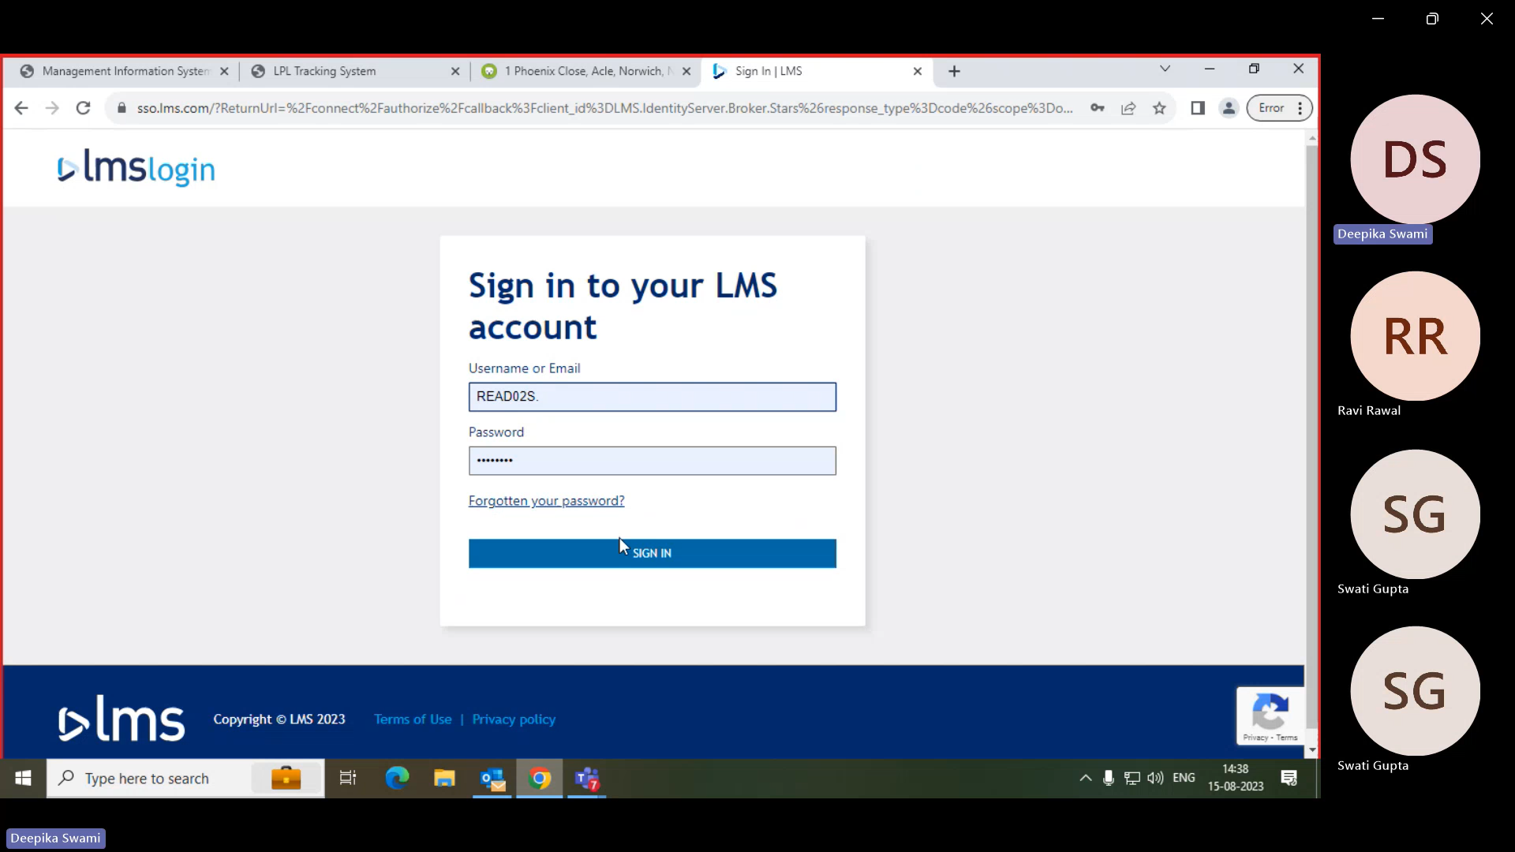

1. Search for Case references and click on view.

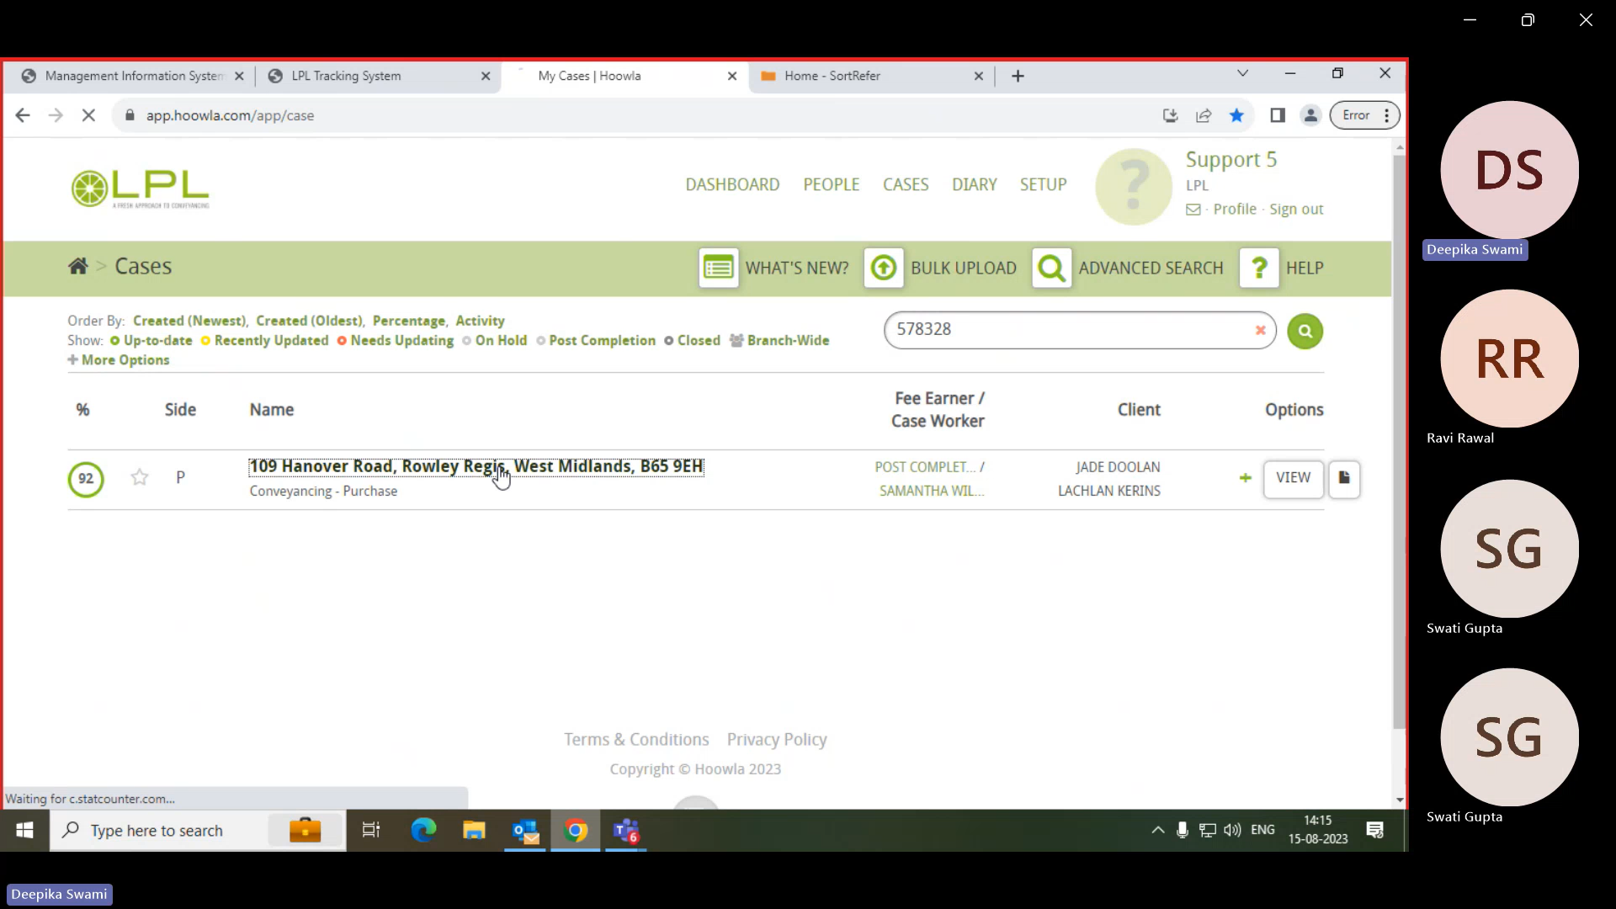

1. Extract the LMS Reference No.

1. Extract the Completion Date and Property Address.

(Condition – If the completion date provided is a date in the future, then bot will encounter an error [Business Exception] in this scenario.)

1. First, select the 'Case' option, then navigate to 'Update Case', and proceed to enter the LMS reference number in the 'Search by Case Number' field then click on search.

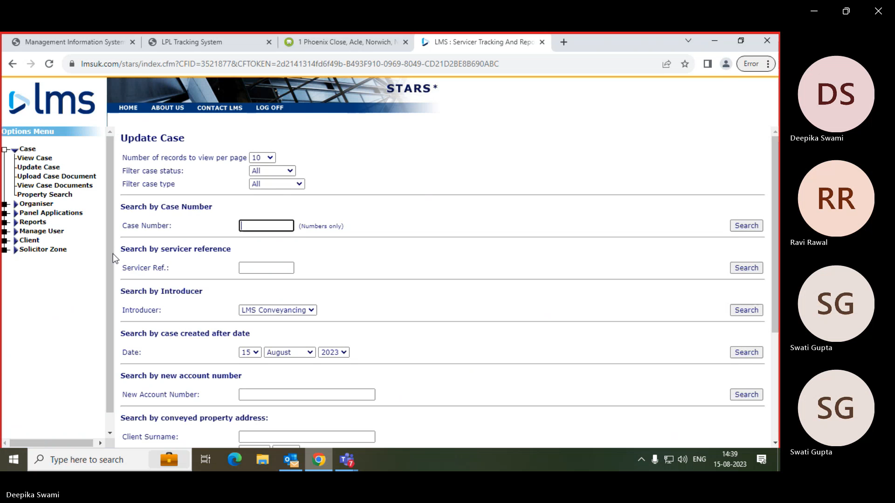

1. Validate the Property address.

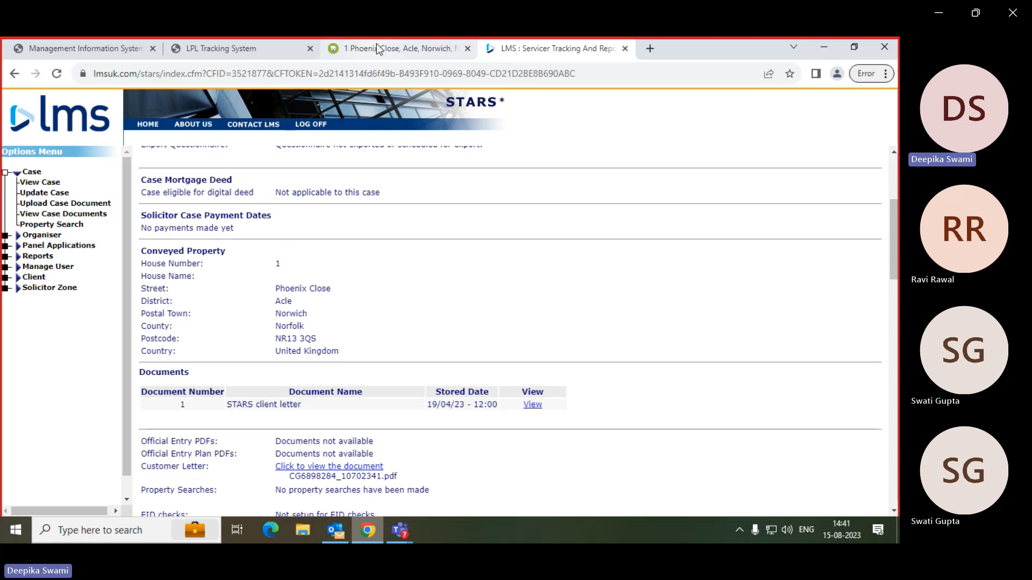

1. Input the completion date in the designated box then click on complete and ensure the rows above are also appropriately filled.

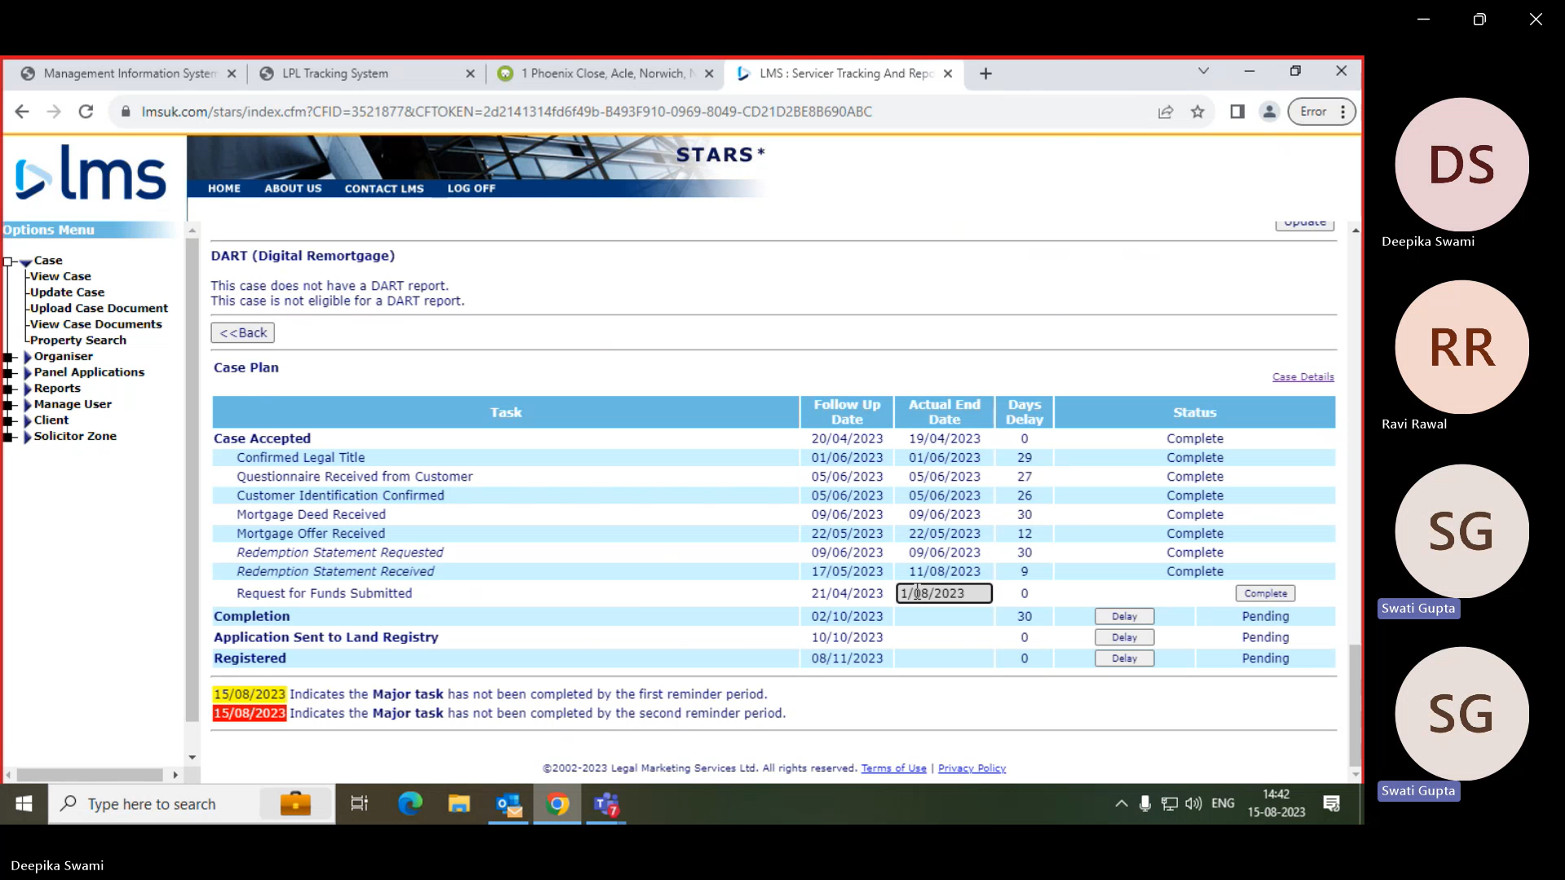

1. If there is delay in case need to add delay reason. (Awaiting instruction from client)

And in dropdown select customer – Chain Option.

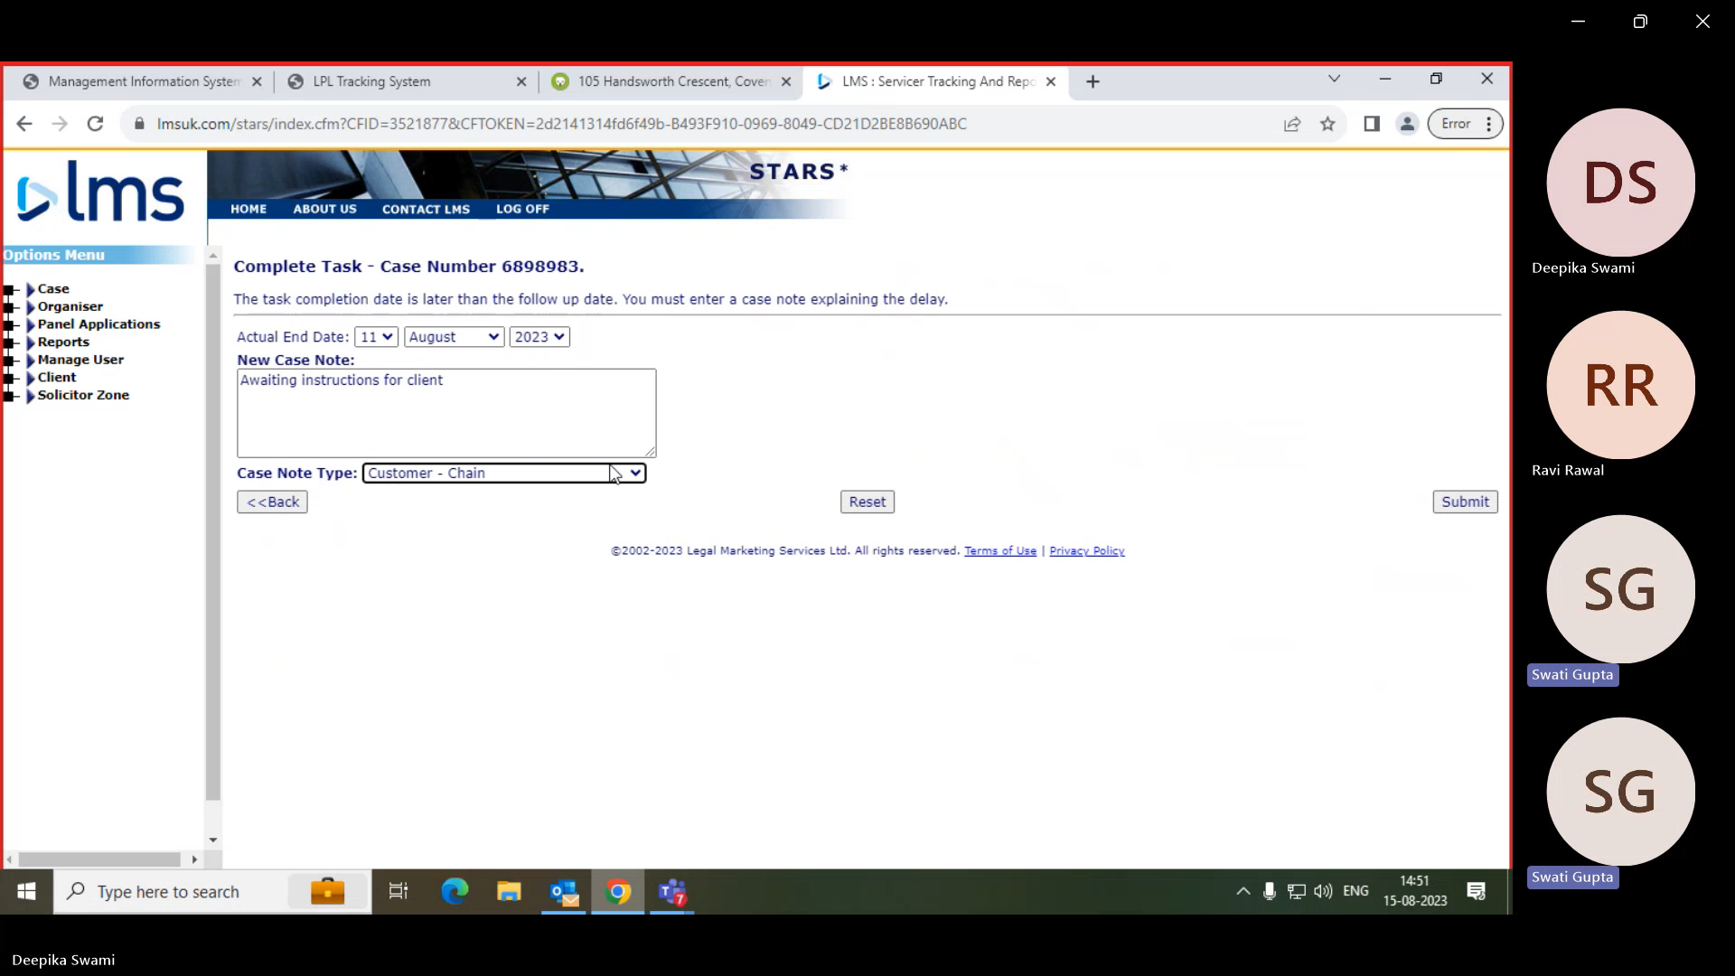

1. If there is no delay in case, then directly on Ok.

